

**FACULTY OF COMPUTING AND INFORMATION TECHNOLOGY**

Programme: RSF2(Group:5)

Bachelor of Computer Science (Honours) in Software Engineering

Year 2 Semester 1

2020 / 2021

**Assignment**

BACS2163 SOFTWARE ENGINEERING

**Bentayan Food Court**

**Online Food Ordering System**

|  |  |  |  |
| --- | --- | --- | --- |
| **Name** | **Registration No.** | **Signature** | **Marks** |
| 1. LIM MING YEU | 20WMR09489 |  |  |
| 1. TAN YONG KANG | 20WMR09517 | C:\Users\User\Pictures\MP Navigator EX\2020_07_29\IMG_0002 (2).jpg |  |
| 1. CHEONG YIN LAM | 20WMR09435 |  |  |
| 1. LEE LING | 20WMR09481 |  |  |
| 1. JOAN HAU | 20WMR09465 |  |  |

Tutor’s Name: MS. MAZLINDA BINTI NEZAM MUDEEN

Date of Submission: 11 September 2020



**FACULTY OF COMPUTING AND INFORMATION TECHNOLOGY**

# Plagiarism Statement and Guideline for Late Submission of Coursework

Read, complete, and sign this statement to be submitted with the written report.

**We confirm that the submitted works are all our own work and are in our own words.**

|  |  |  |  |
| --- | --- | --- | --- |
| **Name** | **Registration No.** | **Signature** | **Date** |
| 1. LIM MING YEU | 20WMR09489 |  |  |
| 1. TAN YONG KANG | 20WMR09517 | C:\Users\User\Pictures\MP Navigator EX\2020_07_29\IMG_0002 (2).jpg |  |
| 1. CHEONG YIN LAM | 20WMR09435 |  |  |
| 1. LEE LING | 20WMR09481 |  |  |
| 1. JOAN HAU | 20WMR09465 |  |  |

Table of Contents

[Plagiarism Statement and Guideline for Late Submission of Coursework 2](#_Toc50721391)

[Chapter 1 5](#_Toc50721392)

[1.1 Organization Background 5](#_Toc50721393)

[1.2 Requirement Gathering Technique 6](#_Toc50721394)

[1.2.1 Observation 6](#_Toc50721395)

[1.2.2 Questionnaire 6](#_Toc50721396)

[1.3 Problem of Existing System 7](#_Toc50721397)

[1.3.1 Inconvenience and time-consuming during ordering food 7](#_Toc50721398)

[1.3.2 Inaccurate calculating profit 7](#_Toc50721399)

[1.3.3 Communication problem between the stall owner and customer 7](#_Toc50721400)

[1.3.4 Difficulties in keeping track of orders 7](#_Toc50721401)

[1.3.5 Limited payment method 8](#_Toc50721402)

[1.4 Software Quality Attributes of the Project 9](#_Toc50721403)

[1.4.1 Functionality 9](#_Toc50721404)

[1.4.2 Reliability 9](#_Toc50721405)

[1.4.3 Security 9](#_Toc50721406)

[1.4.4 Efficiency 10](#_Toc50721407)

[1.4.5 Maintainability 10](#_Toc50721408)

[1.5 Software Process Model 11](#_Toc50721409)

[1.5.1 Process of Incremental Model 11](#_Toc50721410)

[1.5.2 Justifications for choosing Incremental Model 13](#_Toc50721411)

[Chapter 2 14](#_Toc50721412)

[2.1 Project Planning Schedule 14](#_Toc50721413)

[2.2 System Requirements 14](#_Toc50721414)

[2.2.1 Functional Requirements of the Online Food Ordering System 14](#_Toc50721415)

[2.2.2 Non-Functional Requirements 17](#_Toc50721416)

[2.3 Viewpoint Hierarchy 20](#_Toc50721417)

[2.3.1 Viewpoint-Oriented Analysis 20](#_Toc50721418)

[2.3.2 Interactor Viewpoints 21](#_Toc50721419)

[2.3.3 Indirect Viewpoints 21](#_Toc50721420)

[2.3.4 Domain Viewpoint 22](#_Toc50721421)

[Chapter 3 23](#_Toc50721422)

[3.1 Architectural Design 23](#_Toc50721423)

[3.1.1 Repository Model 23](#_Toc50721424)

[3.2 Testing planning and Test Cases 24](#_Toc50721425)

[3.2.1 Testing Process with Tested Item 24](#_Toc50721426)

[3.2.2 Testing Procedures 27](#_Toc50721427)

[3.2.3 Hardware and Software Requirements 36](#_Toc50721428)

[3.2.4 Constraints 36](#_Toc50721429)

[3.3 User Interface Design Principles 38](#_Toc50721430)

[3.3.1 Login Module 39](#_Toc50721431)

[3.3.2 Menu Module 44](#_Toc50721432)

[3.3.3 Order Module 49](#_Toc50721433)

[3.3.4 Payment Module 53](#_Toc50721434)

[3.3.5 Membership Module 58](#_Toc50721435)

[References 62](#_Toc50721436)

# Chapter 1

## Organization Background

Bentayan Food Court is the most famous food court which located at Jalan Bakri, Taman Sri Emas, 84000 Muar, Johor, Malaysia. The name of “Bentayan” food court is based on the street located there, “Jalan Bentayan” and origin from a Malay word “bantaian” which means execute. The story behind is actually from Melaka’s first king, Parameswara refuge to Muar, and during that time he sees a lot of monitor lizard, so his guards hurried executes those monitor lizards.

This Bentayan Food Court has been operated for quite some time, since 1980 and it is the biggest food court in Muar, there are around 20 to 30 stalls can be found in the food court and almost every stall there are time-honored stalls. Each of the stall provide unique type and taste of food in the food court which are all very delicious. This place is like all the special and unique food has all caught in one net. The food court is open every day from 6pm to 10pm.

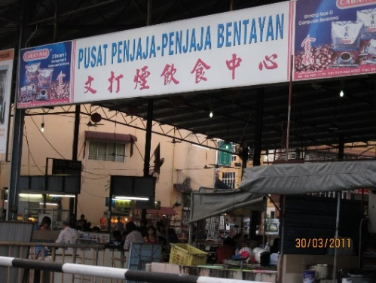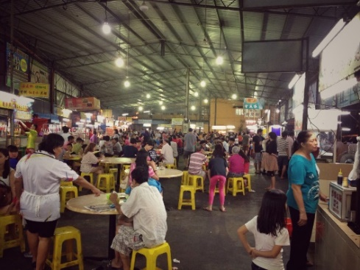The Bentayan Food Court is a traditional food court which only provide self- service for every customer, the customers have to find their own seat, then go to respective stalls to order their food. This food court does not operate their business using any automated system in order to track their order from customer and even income for each of day. All of the business is carried out manually by each of the stall owner in this food court. The stall owner will record down all the order for each of day in a notebook, therefore they can calculate and summarize their own income at the end of the day.

*Diagram 1.1.1 External view of Bentayan Food Court Diagram 1.1.2 Internal view of Bentayan Food Court*

## Requirement Gathering Technique

Requirement Gathering Technique is the technique that is used to perform under a specific situation. It is based on the objective of the project to gather the useful information and data.  The data will analyze to increase the effectiveness of the project.

### 1.2.1 Observation

Through the observation we were able to observe the current operating procedures and watch the sellers and customers go about their usual activities before implementing the system. During the observation, we were able to observe how data flows and who interrelates with whom and how data comes into and leaves the organization. Besides, in order to gather the requirement for the new automated system, we gathered the pros and cons of the current system used so that we can make the improvement and enhancement from the current system used. By using the observation technique, we analyzed the embarrassed and complexed step of the current system used in order to enhance our system in the future. Nevertheless, observation process provided us a better analyst from the gestures and expression of the sellers and customers in Bentayan Food Court while operating the current system. Next, we observed the face expression and hand gestures from the customers during the ordering process of the current system. The face expression and gestures given by the users were able to expose the level of difficulties while using the current system and whether they were adapted to the current system used. Hence, we can use this feedback to unearth the implicit demand that often ignores and too usual for the seller.

### 1.2.2 Questionnaire

Another suitable gathering technique was questionnaire. We prepared some formal list questions about the manual ordering system for analyzing the difficulties level of the manual system. When conducting the questionnaire with the sellers and the customers once they visited the Bentayan Food Court, we had prepared open-ended questions and close-ended questions. Open-ended questions were about the operate interface such as if the manual ordering system is user-friendly and save time. In the closed-ended questions, we ask the satisfaction feelings of the users who used the manual ordering system before and also asked the problem met by the users while using the manual ordering system. Furthermore, in the closed-ended questions we prepared a few questions for asking the users if they think the online ordering system was suitable to implement on this food court and what features are required to improve. In addition, questionnaires were suitable for gathering and analyzing this manual ordering system because some sellers may be shy to speak out their opinion in the interview section, so they can write in the questionnaire with anonymous. Same case to the customers of the Bentayan Food Court, the customers were available to provide opinions and suggestion without filling their personal information.

## Problem of Existing System

Problem of existing system is the disadvantages of the existing system which causes the existing system inconvenience or decreases the efficiency of the current system. The problems of existing system are listed as below:

### 1.3.1 Inconvenience and time-consuming during ordering food

Currently, the Bentayan Food Court is providing self-service and the customers need to go to respective stalls to order their food. This may make customers inconvenience to choose the food that they want to eat because there are around 20 to 30 stalls in Bentayan Food Court and they need to read the menu for each of the respective stall from stall to stall and then make the orders. This may waste a lot of time of customers just for ordering foods.

### 1.3.2 Inaccurate calculating profit

The stall owners will record and calculate the expenses, revenue and profit for each day in a notebook every day. Calculate the profit accurately was quite important for a business to determine whether they are having loss or gain. This manual method was having a low efficiency since the stall owners need a lot of time for the calculation and the result may be inaccurate when the records in the notebook or the calculation have some error.

### 1.3.3 Communication problem between the stall owner and customer

Most of the owners in Bentayan Food Court was a local Chinese in Malaysia so they may unable to communicate in other languages besides of the Chinese since they may didn’t have high level of education level. Hence, they may face some communicate problem with the foreigners due to the language barrier. This was very inconvenient when they need a translation by other people. Besides, some misunderstanding cases may also occur during the ordering when the customer spoke lispingly or the owner hear unclear.

### 1.3.4 Difficulties in keeping track of orders

Currently, the stall owners of Bentayan Food Court record the orders manually on the notebook or without recording but memories it only. Hence, there is some problem that the orders do not follow the sequence according to the time of orders accepted. This has reduced much of the satisfactory level of the customers and their emotion may also be affect. Besides, the owners may forget some of the orders when they didn’t record in the notebook or they forgot to record and this will waste a lot of time of the customers for waiting nothing and also wasting the time of the stall owners to ask for the customers about the food want to order.

### 1.3.5 Limited payment method

Currently, the customers only can pay for the orders by using cash only but there are some disadvantages when pay using cash only. For example, the amount of the payment given by the customers or the changes given by owners might be different with the actual amount of the orders but the receiving party does not realize it. Besides, there is also some risk the cash involved in the payment is fake and it may decrease the profit of the owners. Next, the payment process involves for the calculation of the total, pay of the money and also the changes give back to the customers, this may waste a lot of time and also the owners cannot be focusing on preparing meal. Furthermore, some of the customers may forgot to bring enough of cash or the stall owners didn’t have enough of changes give back to the customers.

## Software Quality Attributes of the Project

The new proposed system to replace the manual ordering system is online ordering system. To replace the manual ordering system, the new propose system having good quality attributes which is important to ensure the system perform well. Below are the software quality attributes of the new propose system:

### 1.4.1 Functionality

The functions of the online ordering system must be able to operate well based on the users’ requirements. For example, the customers are able to view the menu of the specific stall, able to select the food for order and also able to make payment online. Besides, the system able to update the data immediately when users select the food for ordering from different stall. For the price calculation part, the system will update the total payment of the specific order automatically and accurately from time to time. This can prevent inaccurate calculation occurs as before that owners of the stalls have to calculate manually. The owners have saved their time for calculating the total price for each order and also saved time on recording the order details. Besides, with the payment feature of the system, customers are able to pay online for their order and the system will transfer to the specific stall’s owners automatically. Therefore, the customers and the stall’s owners are able to pay and received the exactly amount of the order. Thus, at the end of the day, the stall owners are able to refer back to the ordering details for keeping track their income of the day.

### 1.4.2 Reliability

The online ordering system must be reliability. This is used to ensure the system able to continue operate every day without failure or inaccessible. Besides, the online ordering system is able to deliver the functionality successfully when the users click to proceed the next page or other specific pages. Other than that, online ordering system is required to update the ordering data without failure. There is no error allowed when the order list is submitted to the specific stall’s owner. Furthermore, when the system is reliability without failure, the customers no need to worry if their order is unsuccessful and they also eliminate the action of going to find the specific stall for confirming the order. Having high reliability by the system also helps the stalls’ owner to eliminate their worried about the failure sending of order from customer.

### 1.4.3 Security

The online ordering system must be secure. This is to protect the private data of the stall owners and the members of the food court. The system will only allow authorized users to view their own information. For the stall owners, they are required to log in the system with their user id and password for viewing their order details of their own stall. Besides, for the members log in features, the members are also required to login with their user id and password for getting the benefits such as discount feature that offered by some of the stalls. The system will encrypt the passwords of all of the users, this is to prevent someone hacks to the system and get the password easily.

### 1.4.4 Efficiency

The online ordering system must be able to perform efficiently. During the order process of the system, proceed to the next pages for making order or payment will be loaded in a shorter time. After that, the submitted order will be sent to the stall owners’ side immediately without delay. This helps the customers to save their time on moving to the specific stalls for ordering one-by-one and also helps the stall owners to receive the order details faster and clearer. The stall owners no need to worry again for recording incorrect orders because of misunderstanding about the types of food that ordered by the customers. Some words may sound similar and some customers may not know the Chinese language. These will make misunderstand occurs between the stall owners and the customers as most of the stall owners only able to speak in Chinese and Cantonese. Therefore, by using the online ordering system, the customers who do not know the Chinese may change the menu to the language they wanted through the system. In addition, the stall owners are able to get the correct order details which select and submit by the customers from the websites.

### 1.4.5 Maintainability

The online ordering system must be maintainability. For any error to fix or any updated, it is possible to maintain or modify by the programmers easily. This is because by using a maintainable system, the maintenance programmers can understand the code of the system in a shorter time. Therefore, when maintenance or updated is needed, the food court’s owner is able to find any experienced programmer to code. Moreover, it is possible to modify one of the features of the online ordering system without affects others features such as only modify the menu design. This is because the functions of a maintainability system will be separated to different module and modified one of them will not affect the others function of the system. This helps the food court owner to save their cost on maintenance. Other than that, the system will be able to use for long term because it is able to modify and maintain in the future.

## Software Process Model

The software process model that we recommend for Bentayan Food Court to implement the online food ordering system is an incremental model. There is a total of 5 incremental modules that our group has found for this system.

### 1.5.1 Process of Incremental Model

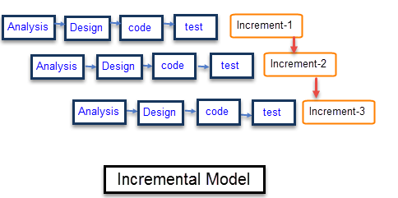

***Diagram 1.5.1.1 Incremental Model Life Cycle***

*(https://www.guru99.com/what-is-incremental-model-in-sdlc-advantages-disadvantages.html)*

There are various phases of the life cycle of incremental model, which are requirement analysis, design, coding, testing, and implementation phase. Each iteration in the incremental model will pass through these phases that stated above. The development team will analyze the requirements obtained and start to implement the system by increment and increment.

#### 1.5.1.1 Increment 1: Register, Login and Logout

At the first incremental of this online food ordering system, the developers design different login forms for customers and the staff of the Bentayan Food Court and a member registration form. Next, a QR scanner function will be implemented during this increment so that the users can scan the QR code to access the online food ordering system. Customers can decide to login the system as a member or visit as a guest. For the login form of the system, the “Remember me” and “Forgot password” functions will be added and a welcome page will be created and display after the user has successfully login. The logout function will also be implemented. Once the implementation for these functions has complete, it will proceed to the testing phase to test and debug each of the functions implemented. If any defects found, the testers will record down all the defects in a document and sent it back to the developers. After all the defects fixed, this increment will deliver to the person who in-charge Bentayan Food Court. The time estimated for this first increment is around 18 days.

#### 1.5.1.2 Increment 2: Menu

Besides that, the menu module with display and update each seller’s menu functions will be implement in second increment. The stall sellers of Bentayan Food Court were able to update their menu details such as food categories, prices, and descriptions. After finish the phase of analysis, design, code and test, it will deliver to to the person who in-charge Bentayan Food Court. The time estimated for this first increment is around 23 days.

#### 1.5.1.3 Increment 3: Order

For the third increment, the order module will be implemented. The developers will add the range of the quantity and “Add to cart” button under each of the food descriptions based on the previous increment. The display, add, and cancel function of the cart will be implemented and for the display function, it will display the summary information of each order such as food name, image, subtotal, and time estimated. After the testing phase done for this increment, it will deliver to the person who in-charge Bentayan Food Court and the third version of the system will be released. The time estimated for this third increment is around 22 days.

#### 1.5.1.4 Increment 4: Payment

For the fourth increment, the payment module will be implemented. A “Proceed to Payment” will be added under the user’s cart that allows users to proceed to the payment page. On the payment page, users can select different payment methods to pay the bills such as paid with debit or credit card, online banking, or TNG e-wallet. The receipt auto-generate function is called after the user successfully make the payment. After the testing phase done for the fourth increment, it will deliver to the person who in-charge Bentayan Food Court and the fourth version of the system will be released. The time estimated for this third increment is around 20 days.

#### 1.5.1.5 Increment 5: Membership

For the firth increment, the membership module will be implemented. The promotion page for members will be created and members able to view the details of the promotion such as the discount rate and due date of the promotion. The firth increment will deliver to the person who in-charge Bentayan Food Court after complete the testing phase and the firth version of the system will be released. The time estimated for this firth increment is around 18 days.

### 1.5.2 Justifications for choosing Incremental Model

There are several justifications for choosing an incremental model to implement the online food ordering system. These justifications are faster initial product delivery, high client interaction with review and feedback to each increment, and easier to test and debug during a small increment.

#### 1.5.2.1 Faster initial product delivery

First, the initial product delivery is faster which means the system will be generated quickly during the system life cycle. Each increment only takes a few weeks to implement. Therefore, the Bentayan Food Court can use the system in their daily operation early and they can provide better services to their customers.

#### 1.5.2.2 High client interaction with review and feedback to each iteration

By using this incremental model, the person who in-charge Bentayan Food Court can respond and review the feature of the system during each increment. He or she has a portion of the system to examine in order to see how well the system meets their requirements and whether the system requirements have to be modified. On another hand, this helps the development team more understanding about the client expectations on a rather regular basis.

#### 1.5.2.3 Easier to test and debug during a small iteration

During the testing phase, the online food ordering system is easier to test and debug because there are only small changes are made during each small increment. Each element within the overall system will be testing by more targeted and rigorous. For example, the subtotal of the order is wrongly calculated in the second increment, the developers can fix the defect easier by going through the order function that implemented in the second increment.

# Chapter 2

## 2.1 Project Planning Schedule

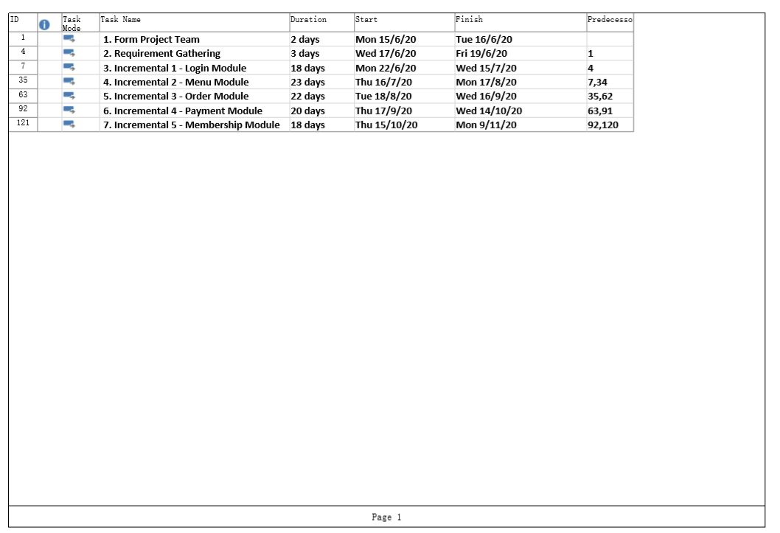

*Diagram 2.1.1 Gantt Chart Description*

## 2.2 System Requirements

System requirements are the descriptions of the system’s services, functions and operational constraints. System requirements are the configuration that ensure the system is running the hardware or software application smoothly and efficiently. The system requirements of the online food ordering system are listed as below:

### 2.2.1 Functional Requirements of the Online Food Ordering System

#### 2.2.1.1 Login Module (for staff and members)

1. The online food ordering system shall allow the customer to **register** a member account.
2. The online food ordering system shall be able to **store** the user id and password of the specific device when the user id and password are valid. (Remember me feature)
3. The online food ordering system shall be able to **send** the one-time Pin (OTP) code to the user’s phone number if the user forgot user id or password. (Forget password feature)
4. The online food ordering system shall allow the customer to **enter** the system as a guest.
5. The online food ordering system shall allow the customer **login** to system as a member.
6. The online food ordering system shall allow the staff **login** to system.
7. The online food ordering system shall allow user to **logout** the system.
8. The online food ordering system shall allow staff to **logout** the system.

#### 2.2.1.2 Menu Module

* For customer

1. The customer shall be able to **view** the menu of the specific stalls.
2. The customer shall be able to **change** the language of the menu.
3. The online food ordering system shall allow the customer to **add** the food to cart for order.
4. The online food ordering system shall allow the customer to **edit** the quantity of the food before adding it to the cart.
5. The online food ordering system shall allow the customer to **delete** the food in the food cart.

* For stall owner
  1. The stall owner shall be able to **add** stall’s menu details such as food categories, prices, and descriptions.
  2. The stall owner shall be able to **edit** the stall's menu details.
  3. The stall owner shall be able to **remove** the stall's menu details.
  4. The stall owner shall be able to **update** the availability status of the stall's menu.

#### 2.2.1.3 Order Module

* For customers

1. The customer shall be able to **add on** a new food to the cart.
2. The customer shall be able to **view** the order in the cart.
3. The customer shall be able to **edit** the food quantity in the cart.
4. The customer shall be able to **delete** the order from the cart.
5. The online food ordering system shall be able to **display** the summary information of each order details such as food name, image, quantity and subtotal.

* For stalls’ owners

1. The stall’s owner shall be able to **view** the receiving online order.
2. The stall’s owner shall be able to **delete** an online order.
3. The stall’s owner shall be able to **update** the online order details.

#### 2.2.1.4 Payment Module

* For customers

1. The online food ordering system shall be able to **calculate** the subtotal for each type of food.
2. The online food ordering system shall be able to **calculate** the total payment.
3. The customer shall be able to **view** the payment details.
4. The customer shall be able to **pay** with a debit card.
5. The customer shall be able to **pay** with a credit card.
6. The customer shall be able to **pay** with TNG e-wallet.
7. The customer shall be able to **pay** with cash.
8. The online food ordering system shall be able to **generate** a digital receipt after the payment is made successfully when the customer pays with debit or credit card.
9. The online food ordering system shall be able to provide promotion to the members.

* For stall’s owners

1. The online food ordering system shall be able to **generate** the received order details of the day.
2. The online food ordering system shall be able to **generate** the report of the week.
3. The online food ordering system shall be able to **generate** the report of the month.

#### 2.2.1.5 Membership Module

* For food court’s members

1. The member shall be able to **view** the details of the promotion such as the promotion price for the current day.
2. The member shall be able to **retrieve** the promotion when making an order and payment.
3. The member shall be able to **rate** on the food of the specific stall.
4. The online food ordering system shall allow the member to **change** the account's password.

* For stall owner

1. The stall owner shall be able to **view the stall's** promotion details.
2. The stall owner shall be able to **update the stall's** promotion details.
3. The stall owner shall be able to **add the stall's** promotion details.
4. The stall owner shall be able to **delete the stall's** promotion details.
5. The online food ordering system shall be able to **edit** the promotion details.

### 2.2.2 Non-Functional Requirements

#### 2.2.2.1 Product

##### Security

* The online food ordering system shall validate the username and password in order to login.
* The online food ordering system shall only allow authorized users to login.
* The online food ordering system shall request the current password of the user for changing of password.
* The online food ordering system shall be able to **encrypt** the password for the users.
* The online food ordering system shall be able to **encrypt** all the transaction data before store into the database.

##### Usability

* The user interface for the online food ordering system shall be implemented by using **FLUTTER.**
* The online food ordering system shall have a user-friendly interface and easy to learn which allows the user to easily use the system in a short time.
* The online food ordering system shall let the user easily understand the functionality of each module.

##### Availability

* The online food ordering system shall be accessible by the users at all time, only restricted by the down time of the server on which the system runs.

##### Reliability

* The online food ordering system shall be able to operate every day without failure or inaccessible.
* The online food ordering system shall only allow it to be down during maintenance period at midnight.

##### Maintainability

* The commercial database is used for maintaining the database and the server is used for maintaining the system.

##### Portability

* + - * The online food ordering system shall be able to move from one operating system to another operating system and does not cause any problem.

##### Performance

* + The online food ordering system shall have a fast performance and be able to perform all functionality in a short time.
  + The online food ordering system shall be able to handle 200 users at one time without affecting the performance.

#### 2.2.2.2 Organization

##### Project Duration

* The online food ordering system shall be implemented using an incremental model.
* The first increment of the online food ordering system which is the login module shall be done in 1 week which include the validation feature on user id and password.
* The second increment of the online food ordering system which is the menu module shall be done in 1 week which can display and update the menu.
* The third increment of the online food ordering system which is the order module shall be done in 2 weeks which enables the users to add the food into cart and place order.
* The fourth increment of the online food ordering system which is the payment module shall be done in 2 weeks which enables the users to pay for the order.
* The fifth increment of the online food ordering system which is the membership module shall be done in 2 weeks which provide extra function for the member.

##### Project Methodology

* The online food ordering system shall be developed using the Design Development Methodology and Object-Oriented Analysis.

##### Database Tool

* The online food ordering system shall be implemented based on the Oracle database.
* The database shall be capable of storing all the data of the user.
* The database shall be capable of storing 1 million transaction records.

#### 2.2.2.3 External

##### Privacy

* The online food ordering system shall not **disclose** any personal information about system users apart from name, IC number, phone number to the stall owners and outsiders.

##### Legislative

* The online food ordering system shall include 6% of Sales and Service Tax in each order that conforms to Malaysia law.

## 2.3 Viewpoint Hierarchy

Viewpoint Hierarchy is a way to analyze and discover the potential stakeholders to detect the requirements. Viewpoints can assort the stakeholders depending on the requirements when they are using the system. Below is the viewpoint-oriented analysis for the online food ordering system:

### 2.3.1 Viewpoint-Oriented Analysis

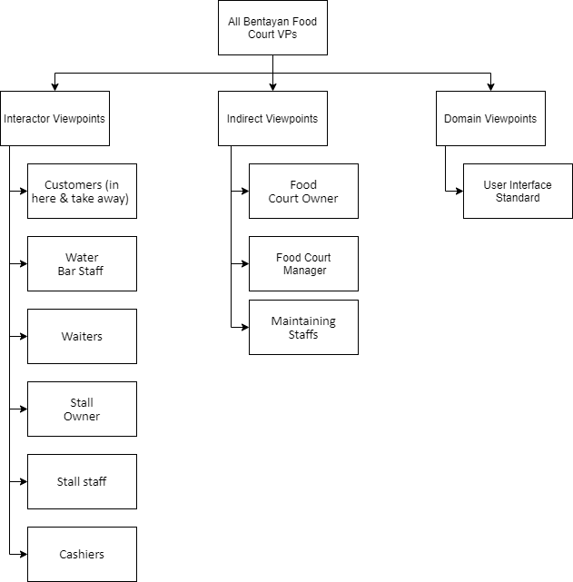

*Diagram 2.3.1 Viewpoint Hierarchy*

### 2.3.2 Interactor Viewpoints

* Customers

When customer order the food whether they want to eat in food court or take away, they can directly use the newest ordering system to order food from each stall. They no need walk through all the stall to see their menu and just need to sit at any numbered table.

* Water Bar Staff

The water bar staff will according to the system of ordering drinks from each table of customers to prepare and make the drinks.

* Waiters

The waiters will be based on the system instruction to send out each drink to each respective table from the water bar. Waiters can also use the system to track the order due to customers complaint too late.

* Stall Owner

When each stall owner receives the order from the system, they will start to prepare the food.

* Stall Staff

Each stall owner staff will be based on the number of tables in system provided to deliver the meat from their stall to respective table.

* Cashiers

After customers finish eating, they can base on the bill in the system to pay the bill to cashier or through the waiters to deliver to the cashier.

### 2.3.3 Indirect Viewpoints

* Food Court Owner

Food Court Owner will be based on the general food court ordering system to give general requirements. Due to 20 to 30 stalls in Bentayan Food Court, the food court owner will gather most of the stall owner agree the special requirements to add the requirements.

* Food Court Manager

Food Court Manager is using the system to manage each stall of the complaint from the customers. For example, the cleanliness of each table, the error of the order, the error of the ordering system and so on.

* Maintaining Staff

Maintaining Staff need to maintain the system to ensure the system is availability and usable for customers. If the ordering system face some error while ordering, they need to solve the problems as fast as possible.

### 2.3.4 Domain Viewpoint

* User Interface Standard

User Interface Standard is to ensure the user interface is can be easily and simple to use by the users like customers, staff, stall owner in Bentayan Food Court. User Interface is to increase the satisfactory of customers when they using the ordering system.

# Chapter 3

## 3.1 Architectural Design

Architectural Design is a process to analyse the initial stage in the design process. The initial stage of design process is to identify the sub-system and make up a system and framework to let the sub-system to control and convey.

### 3.1.1 Repository Model

**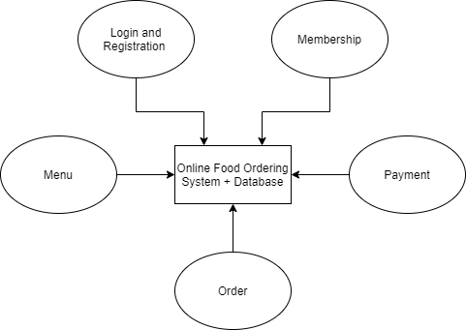**

*Diagram 3.1.1 Repository Model for Online Food Ordering System*

The Online Ordering Food System is required to share a large amount of data to all the stall owners and the cashier on each day. For example, the food order by each table of customers, the total amount they need to pay, sending the order of drinks to the water bar and so on. Online ordering system also needs to communicate with the sub-system and interchange the data in order to pass the ordering data through the database to each stall owner and water bar staff to prepare the food and drinks. Other than that, databases act as centralised management to backup and secure the data that is ordered by each table and payment. Since, there are around 20 to 30 stalls in Bentayan Food Court and up to 60 tables, so the database needs to store and backup the large amount of data in order to confirm all the data will not confuse and have the proof that the customers have ordered before.

Repository model not only needs to store and share the ordering data, it also needs to let the user login or register into the database. Online food ordering systems need to display the menu and update the latest promotion details of the stall for all the customers in Bentayan Food Court. The members can also see their membership discount and retrieve the promotion provided by the stall owner. After finishing eating, the repository needs to share the total payment for the cashier to let the customers pay on the bill.

#### 3.1.2 Justification

In the online ordering system, we need a system organization model **to store and share large amounts of data to different sub-system**. For example, the stall owners need to receive a large amount of order from customers and the cashier needs to carry out the membership and the promotions of data to the payment in Bentayan Food Court.

Besides that, the repository model also acts as a **centralized database**, it can backup, update and encrypt the data that needs to transfer within the sub-system and it can prevent the data from being amended by other people. Repository model also can update the promotion set meal on the menu, so the customers will receive the newest promotion menu.

Next, the sub-system **no need to concern on how the data is produced,** so it will not affect and burden on the data process within the system. So, the repository model is the most suitable to fulfil the online ordering food system requirements. Repository also act as centralized model to communicate with sub-system to share large amounts of data and encrypt the data to ensure the order will not be changed by other people.

## 3.2 Testing planning and Test Cases

The testing is to demonstrate to the developer and the customer that the software meets the requirements and to discover faults or defects in the software where the behaviour of the software is incorrect, undesirable or does not conform to its specification. Below is the testing process and stage that will be carried out in our project of online food ordering system:

### 3.2.1 Testing Process with Tested Item

#### 3.2.1.1 Unit Testing

The unit testing will be carried out during each of the development stage in each of the incremental. The unit testing will be carried out when one function of the module is prepared. This testing will mainly focus on the functionality in each of the module. The unit testing will be only focus on minor part of the module.

##### Tested Item

1. Login Module

* Registration Form for Customer
* Login Form for Customer
* Display Welcome Page
* Customer Registration
* User Login

1. Menu Module

* Display Menu
* Update Menu

1. Order Module

* Display the Order for User
* Update the Order for User and Stall Owner
* Add to Cart Function

1. Payment Module

* Proceed to Payment Function
* Multiple Payment Method for User
* Display Digital Receipt for User

1. Membership Module

* Display the Promotion Page
* Selecting Promotion Item
* Display Rating Page
* Rate the Stall

#### 3.2.1.2 Module Testing

The module testing will be taking place once all the function in the module is completed. The module testing is to make sure that all the related functionality in the module can be work wisely and perform efficiently in the usual operation.

##### 3.2.1.2.1 Tested Item

* Login Module
* Menu Module
* Order Module
* Payment Module
* Membership Module

#### 3.2.1.3 Sub-system Testing

This testing will be carried out after the first incremental model. This testing is to test the combination of the module for each of the incremental stage. This testing is to test the interactions between the integrated components

##### Tested Item

* (incremental 2) Login Module + Menu Module
* (incremental 3) Login Module + Menu Module + Order Module
* (incremental 4) Login Module + Menu Module + Order Module + Payment Module

#### 3.2.1.4 System Testing

The system testing will be carried out at the last stage of the incremental in order to make sure all the functionality perform smoothly and is well prepared.

##### Tested Item

* (incremental 5) Login Module + Menu Module + Order Module + Payment Module + Membership Module

#### 3.2.1.5 User Acceptance Testing

This testing is the final stage of the testing before the module is completed to be promote to the client during each of the increment. This testing is to ensure that the user is able to use the function in a proper way without any bugs.

##### Tested Item

* (incremental 1) Login Module
* (incremental 2) Menu Module
* (incremental 3) Order Module
* (incremental 4) Payment Module
* (incremental 5) Membership Module

### 3.2.2 Testing Procedures

|  |  |  |  |  |  |
| --- | --- | --- | --- | --- | --- |
| **Program Name: Online Food Ordering System (Login Module)**  **Test Date: 2 June 2020 – 9 June 2020 (6 days) Tester: Joan Hau** | | | | | |
| **No** | **Objective/Test Cases** | **Test Data** | **Expected Results** | **Actual Results** | **Remarks/ Comments** |
| 1 | To register a member account | User Details | Successfully **registered** user |  |  |
| 2 | To store the User ID and password of the specific device.  (Remember Me Feature) | User Details  ‘Tick’ the remember me button | Successfully **stored** the user information |  |  |
| 3 | To send the one-time Pin (OTP) code to user’s phone number | Click the forget password link  User phone number  Click send OTP | Successfully **sent** the one-time Pin |  |  |
| 4 | To enter the system as a guest | Click the ‘visit as a guest’ button | User successfully **entered** the system as a guest |  |  |
| 5 | To login to the system as a member | Member Details  Click the login button | Member successfully **login** |  |  |
| 6 | To login to the system as a staff | Staff details  Click the login button | Staff successfully **login** |  |  |
| 7 | To logout the system | Click the logout button | Successfully **exit** the system |  |  |

|  |  |  |  |  |  |
| --- | --- | --- | --- | --- | --- |
| **Program Name: Online Food Ordering System (Menu Module)**  **Test Date: 29 June 2020 – 10 August 2020 (9 days) Tester: Lee Ling** | | | | | |
| **No** | **Objective/Test Cases** | **Test Data** | **Expected Results** | **Actual Results** | **Remarks/ Comments** |
| 1 | To view the menu of the specific stalls | Click the go to stall button at the site of a specific stall | Successfully **displayed** the menu list of the specific stall |  |  |
| 2 | To change the Language of the menu | Click the change language button | Successfully **changed** from one language to selected language |  |  |
| 3 | To add the food to cart for order | Selected food details  Click the add to cart button | Successfully **added** the selected food into food cart |  |  |
| 4 | To edit the quantity of the food | Selected food details  Click add and minus icon | Successfully **changed** the quantity of the food |  |  |
| 5 | To delete the food in the food cart | Selected food details  Click the dustbin icon | Successfully **deleted** the selected food |  |  |
| 6 | To add the stall’s menu | Click the new food button Food details and status  Click save button | Successfully **added** new food into the menu |  |  |
| 7 | To edit the stall’s menu | Selected food details  Click the pen icon at the specific food  Food details  Click save button | Successfully **changed** the food details |  |  |
| 8 | To remove the stall’s menu | Selected food details  Click dustbin icon at the specific food  Click yes button | Successfully **removed** the food details |  |  |
| 9 | To update the status of the food in the menu | Selected food details  Click the pen icon at the specific food  Selected food status  Click save button | Successfully **changed** the food status to the selected status |  |  |

|  |  |  |  |  |  |
| --- | --- | --- | --- | --- | --- |
| **Program Name: Online Food Ordering System (Order Module)**  **Test Date: 31 August 2020 – 9 September 2020 (8 days) Tester: Cheong Yin Lam** | | | | | |
| **No** | **Objective/Test Cases** | **Test Data** | **Expected Results** | **Actual Results** | **Remarks/ Comments** |
| 1 | To add on the food to the cart | Selected food details  Click the add to cart button | Successfully **added** the food into food cart |  |  |
| 2 | To view the order in the cart | Click the cart icon | Successfully **displayed** the order listing |  |  |
| 3 | To edit the food quantity in the cart | Selected food details  Click the add and minus icon | Successfully **edited** the food quantity for the selected food |  |  |
| 4 | To delete the order from the cart | Selected food details  Click the dustbin icon at the specific food | Successfully **deleted** food in the cart |  |  |
| 5 | To display the summary of the order details | Click the proceed to payment button  Order details | Successfully **displayed** the summary of the order details |  |  |
| 6 | To view the receiving online order | Click the order details | Successfully **displayed** the order received |  |  |
| 7 | To update the status of the order details | Click the correct icon for the selected order  Order details  Click yes button | Successfully **changed** the correct icon from orange color to grey color with double tick |  |  |
| 8 | To delete the order received | Click Edit button  Click the dustbin icon for the selected order details  Order details | Successfully **deleted** the order received, change the dustbin icon from red color to grey color |  |  |

|  |  |  |  |  |  |
| --- | --- | --- | --- | --- | --- |
| **Program Name: Online Food Ordering System (Payment Module)**  **Test Date: 28 September 2020 – 7 October 2020 (8 days) Tester: Tan Yong Kang** | | | | | |
| **No** | **Objective/Test Cases** | **Test Data** | **Expected Results** | **Actual Results** | **Remarks/ Comments** |
| 1 | To calculate the subtotal for each of the food | Food prices and quantity  Order details | Successfully **calculated** the subtotal of the order without tax |  |  |
| 2 | To calculate the total payment | Food prices and quantity  Order details  Subtotal of the order  Tax | Successfully **calculated** the total payment of the order with tax |  |  |
| 3 | To view the payment details | Order details  Click the proceed to payment button | Successfully **displayed** the payment details |  |  |
| 4 | To pay with debit card | Order details  Select the payment method to debit card  Card details  Click proceed button | Successfully **proceeded** to related bank |  |  |
| 5 | To pay with credit card | Order details  Select the payment method to credit card  Card details  Click proceed button | Successfully **proceeded** to related bank |  |  |
| 6 | To pay with TNG e-wallet | Order details  Select the payment method to TNG e-wallet | Successfully **displayed** the QR code. |  |  |
| 7 | To Pay with cash | Order details  Select the payment method to pay with cash | Successfully **displayed** the QR code. |  |  |
| 8 | To generate the digital receipt | OTP number  Click submit button | Successfully **displayed** the digital receipt |  |  |
| 9 | To provide promotion to members | Member login | Successfully **provided** the discount for the member order. |  |  |
| 10 | To generate the received daily report | Click daily report button | Successfully **displayed** the daily report |  |  |
| 11 | To generate the received weekly report | Click weekly report button | Successfully **displayed** the weekly report |  |  |
| 12 | To generate the received monthly report | Click monthly report button | Successfully **displayed** the monthly report |  |  |

|  |  |  |  |  |  |
| --- | --- | --- | --- | --- | --- |
| **Program Name: Online Food Ordering System (Membership Module)**  **Test Date: 23 October 2020 – 3 November 2020 (8 days) Tester: Lim Ming Yeu** | | | | | |
| **No** | **Objective/Test Cases** | **Test Data** | **Expected Results** | **Actual Results** | **Remarks/ Comments** |
| 1 | To view the promotion details | Click the promotion button at the side bar | Successfully **displayed** the promotion details |  |  |
| 2 | To rate the stall | Click the rating button at the side bar  Click and give the star for the food of the specific stall  Click submit | Successfully **rated** on the food of the specific stall |  |  |
| 3 | To change the member account password | Click the profile button at the side bar  Click the pen icon at the password column  Password details  Click confirm button | Successfully **changed** the password for the specific account. |  |  |
| 4 | To view the stall’s promotion | Click the promotion button | Successfully **displayed** the promotion of the stall |  |  |
| 5 | To add the promotion | Click new promotion button  Promotion details  Food details | Successfully **added** the promotion of the stall |  |  |
| 6 | To delete the promotion details | Click dustbin icon at the specific promotion  Selected promotion | Successfully **deleted** the promotion of the stall |  |  |
| 7 | To edit the promotion details | Click the pen icon at the specific promotion  Selected promotion  Promotion details | Successfully **edited** the promotion of the stall |  |  |

### 3.2.3 Hardware and Software Requirements

* Samsung Note 9
  + OS Android 8.1
* Redmi Note 9
  + OS Android 10
* iPhone 8s Plus
  + OS iOS 13
* Google Chrome
* Android Studio

### 3.2.4 Constraints

#### 3.2.4.1 Test Item Availability

All the item needed for testing must be always well prepared before the start of the testing process. Item such as the module that need to be developed in each stage of the incremental must always be well prepared before the testing process take place.

* 1st Scenario

Scenario: The functionality of the module is not well prepared and completed during the testing process.

Solution: Both programmer and tester carried out the testing and development at the same time to ensure the module can be done in the specific time frame.

* 2nd Scenario

Scenario: The functionality is not meet the client requirement

Solution: Programmer will be continuing develop the function in the module and the testers carried out their testing at the same time.

#### 3.2.4.2 Test Resources Availability

The resources which consists of software, hardware, staff and others must always be standby before the testing process. The staff that in charge in testing the program must be available during the testing. The hardware and software must be able to work properly during the testing in order to make sure all the things can be done in time.

* 1st Scenario

Scenario: The tester is not enough to complete the testing process due to the leave taken by the staff.

Solution: Manage the leave of the staff which involved in the testing process. Avoid numbers of staff take the leave in a week.

* 2nd Scenario

Scenario: Some of the hardware of the staff is not able to support the testing of the program

Solution: Upgrade the specification of the hardware for the staff in order to make sure the testing can be run successfully

#### 3.2.4.3 Time Constraint

The time constraint will determine the time frame of the project or task. The program must be start on 15 June 2020 and end on November of 2020. The project will need to finish all the process in time before promote to the real-world environment.

* + - 1st Scenario

Scenario: The time given for the test is too short

Solution: Prepared the Gantt chart for pre-preparation of the whole process in order to ensure all the testing can be done in the period of time given by the client

## 3.3 User Interface Design Principles

The selected user interface principle to be applied on online food ordering system:

* Consistency
  + The operations of the online food ordering system were always activated in the same way.
* Minimal Surprise
  + The users of the online food ordering system should never be surprised by the behaviour of the system.
* User Guidance
  + The online food ordering system will provide help feature and meaningful feedback to the user when errors occur.
* Recoverability
  + The online food ordering system will allow the users to recover from the errors.
* User Familiarity
  + The online food ordering system is using the terms and concepts which are drawn from the experience of the users.
* Reduce the user’s memory load
  + The users of the online food ordering system will only have limited short-term memory to prevent the users from making mistakes when they handle too much info.

### 3.3.1 Login Module

#### 3.3.1.1 User Familiarity

The design of the login module for this online food ordering system is work familiar with other existing food ordering systems. The interface of this module also uses the terms and concepts which are drawn from the experience of the people who will make most use of the system. For example, the login module lets the user login by entering the id and password which is always similar to the term and design of others food ordering system and even login page of others system. This design principle can make users easy to use as it consists of similar design and term with other systems.

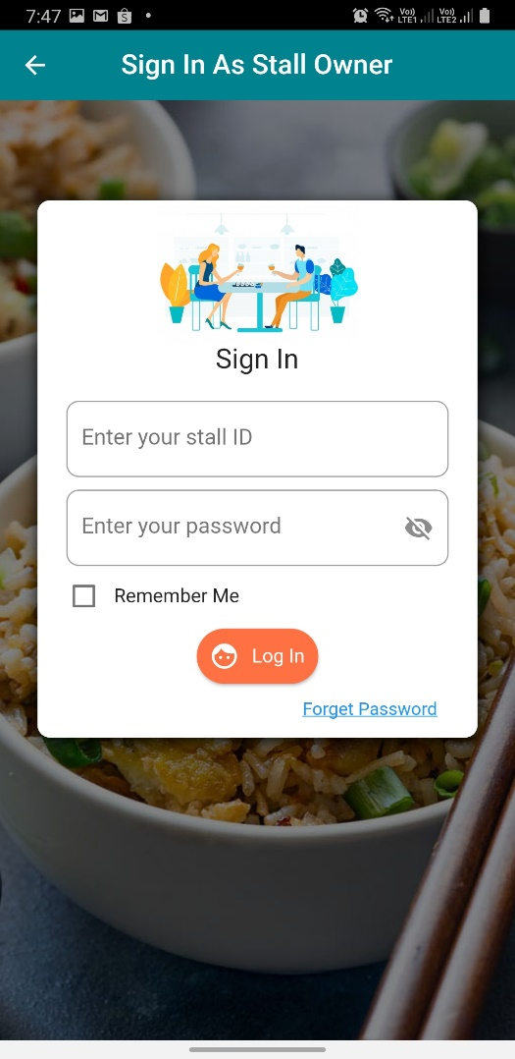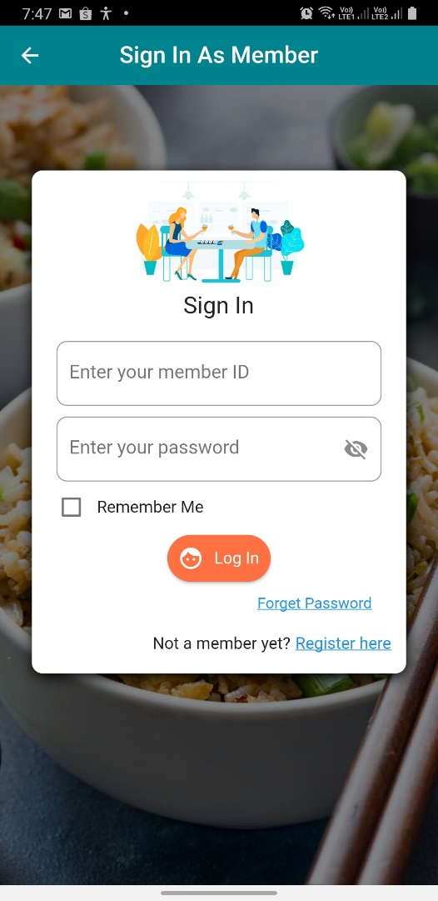

*Diagram 3.3.1 Member Login Page Diagram 3.3.2 Staff Login Page*

#### 3.3.1.2 Consistency

The operation in the login module is activated in the same ways. For instance, the main operation of the login module will be placed at the centre of the screen and other help features are always placed at the side of the screen with attractive colour in order to let the user know there is the function provided for guidance. The format used in this module is always the same to minimize the confusion among the user towards the operation of the system.

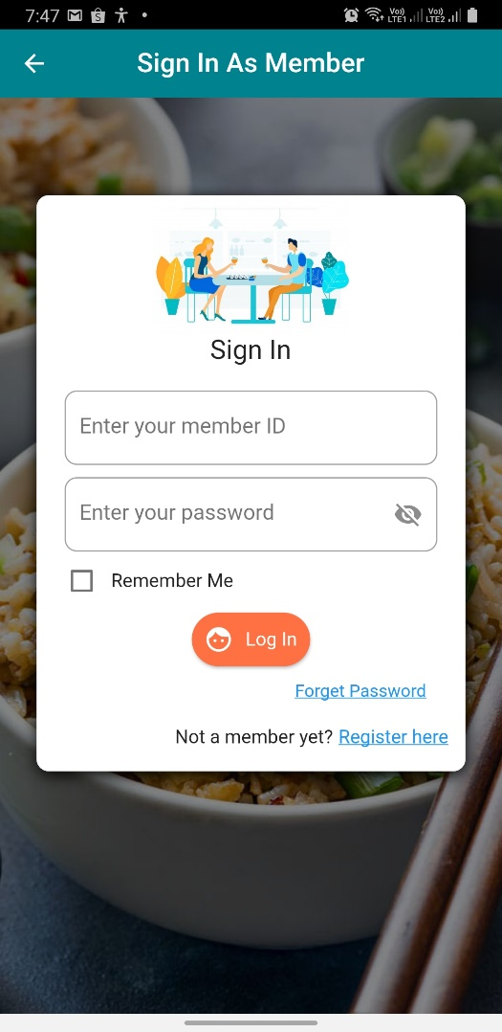

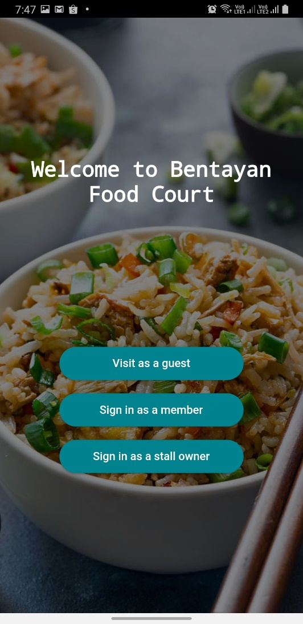

*Diagram 3.3.3 Welcome Page Diagram 3.3.4 Member Login Page*

#### 3.3.1.3 Minimal Surprise

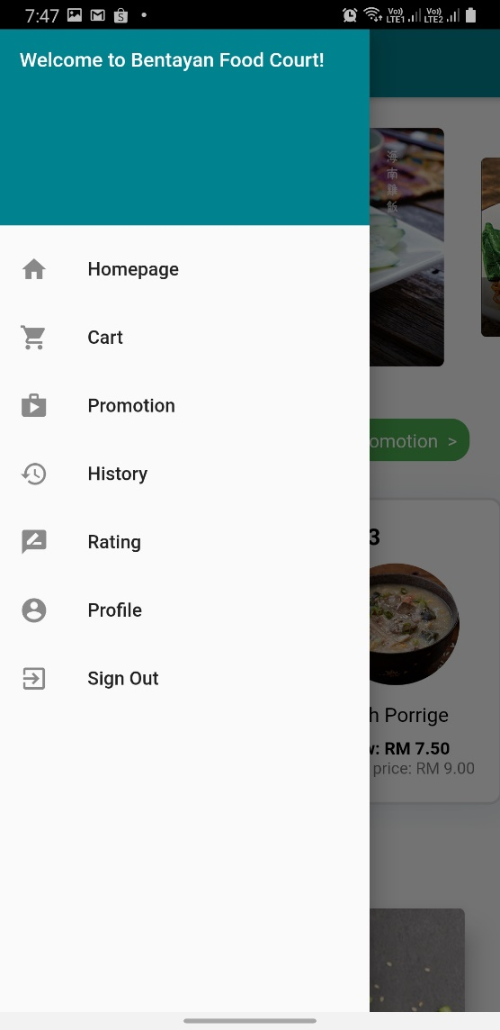The users of online food ordering system will never be surprised by the behaviour of the system. For example, the online food ordering system will never suddenly close and never jump from login page to another page when using. For the users who want to log out from the system, the system will always ask for confirmation before carrying out the process in order to minimize the surprise and to let the users know which step, they are going to proceed with.

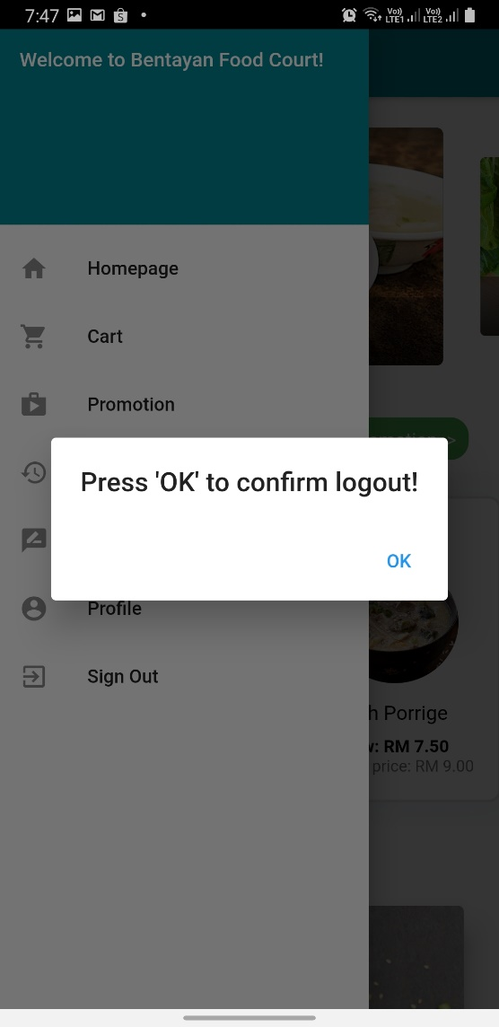

*Diagram 3.3.5 Side bar Diagram 3.3.6 Confirm Logout*

#### 3.3.1.4 User Guidance

The login module also uses the user guidance design principles during the development phase. This module will provide help and meaningful feedback when errors occur. When the user enters the wrong username or password during login, the system will display the error message to inform the user. The column also will show green colour to inform the user which step they currently do in order to guide the user. For example, when the user enters the id column, the id column will be surrounded with green colour, so that the user can understand that they are at the id column and need to enter the id.

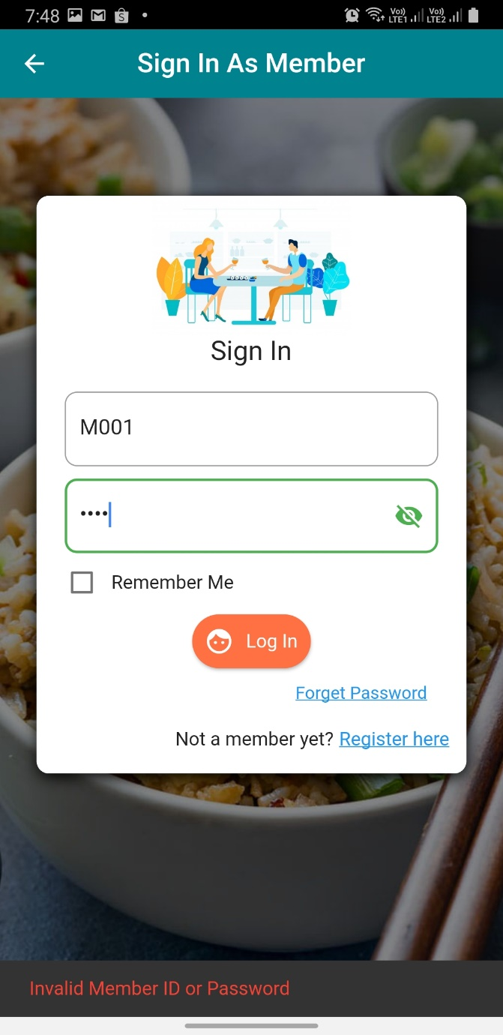

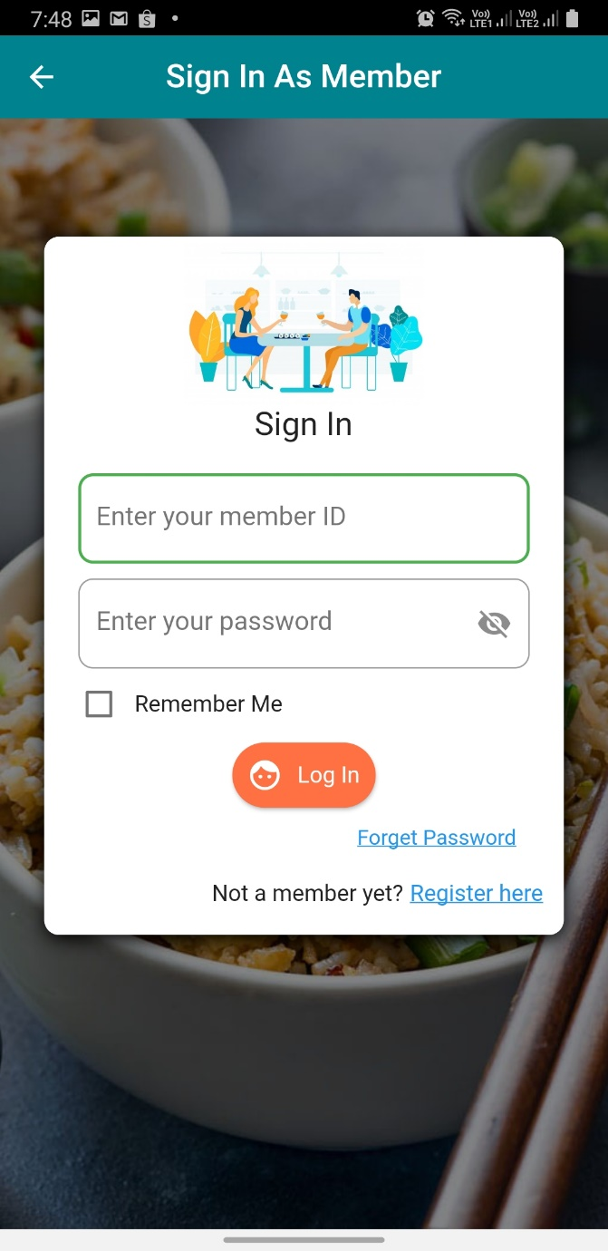

*Diagram 3.3.7 Member Login Page Diagram 3.3.8 Error Message*

#### 3.3.1.5 Recoverability

The login module allows the users to recover from errors. The users can always undo their data when they entered the wrong data. For example, when the user enters the wrong username or password during login, the online food ordering system will allow the user to enter the username or password again. Besides, when the user accidentally clicks the sign out button at the side bar, the user can always return to the same page by click the return button.

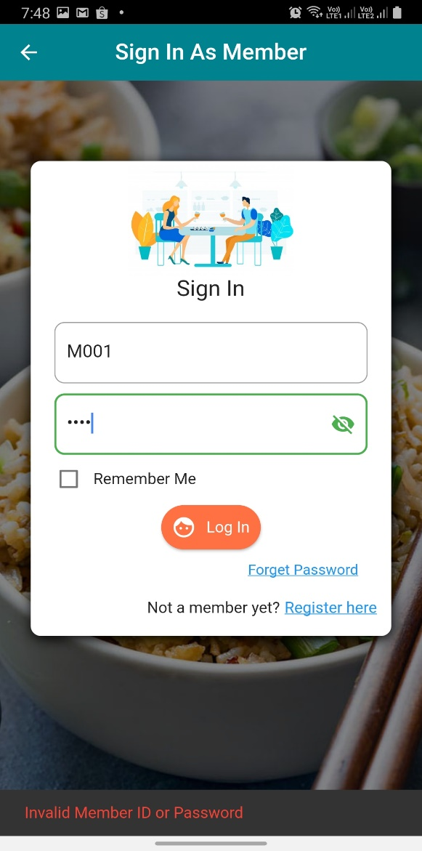

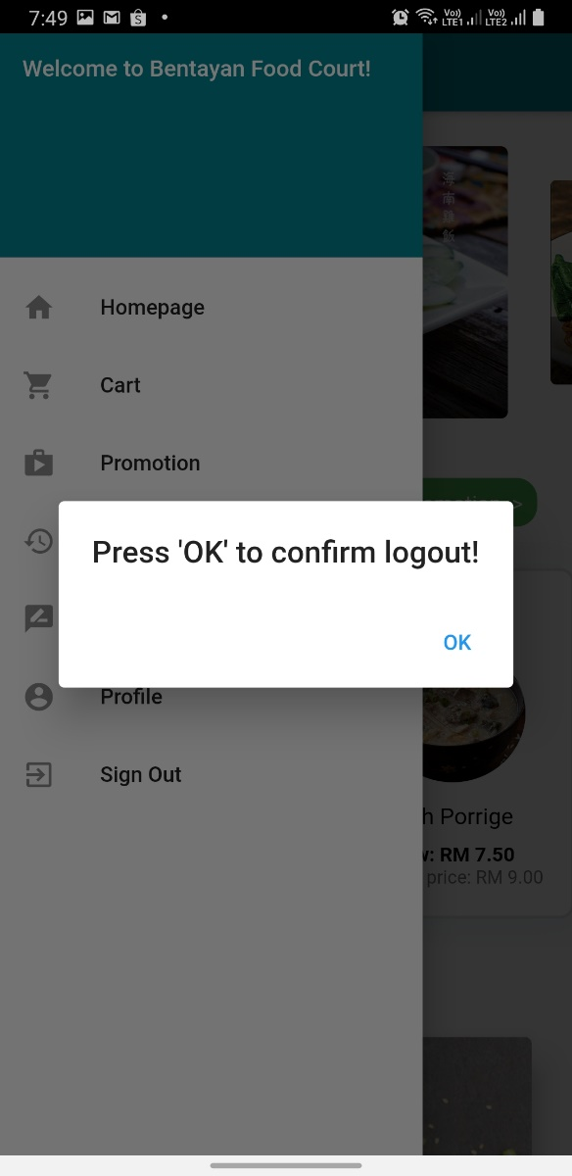

*Diagram 3.3.9 Logout Confirm Diagram 3.3.10 Member Login Page*

### 3.3.2 Menu Module

#### 3.3.2.1 User Familiarity

The interface of the menu module of the online food ordering system is using terms and concepts which are drawn from the experience of the people who will most use the online food ordering system. For example, the user orders the foods by adding the foods to the cart. The terms such as ‘Add to cart’ is drawn from people adding the products into the cart during shopping in supermarkets.

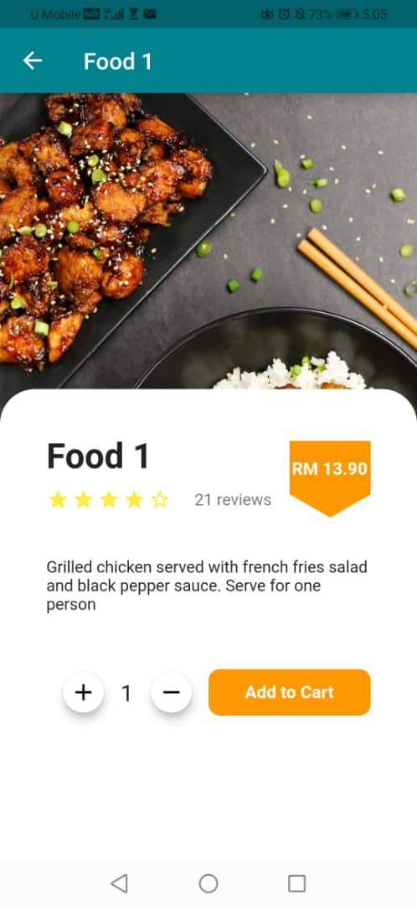

*Diagram 3.3.11 Food Details Page*

#### 3.3.2.2 Consistency

The ways to display the text and the picture are all the same in the menu module. For example, the menu module is displaying the picture and then the stall name, description and then the go to stall button. This can make the menu module easy to learn and reduce confusion of the users when they are using the system.

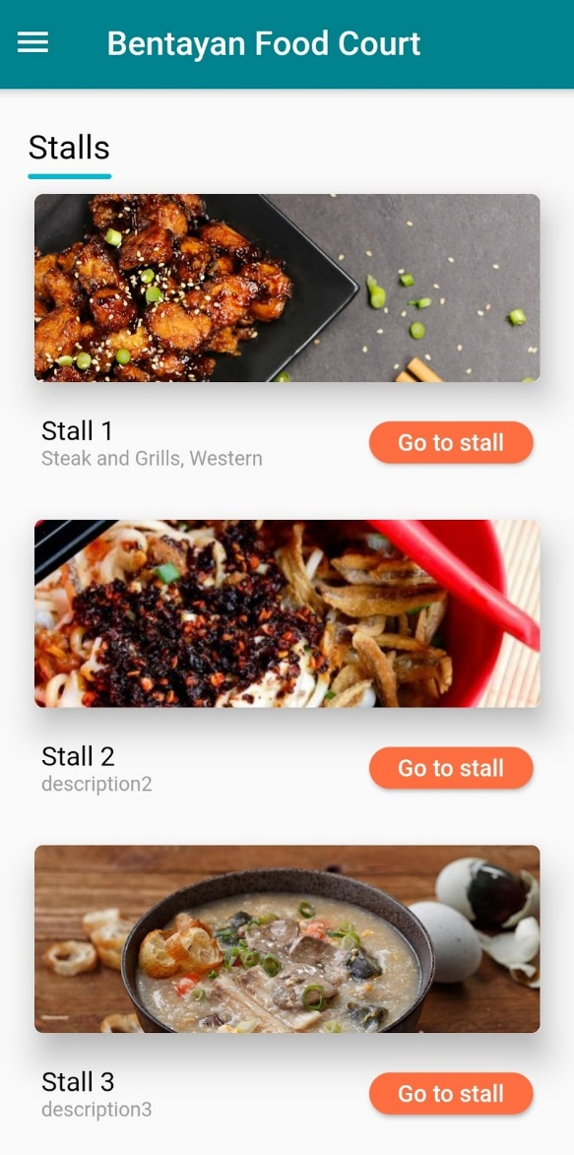

*Diagram 3.3.12 Menu Page*

#### 3.3.2.3 Reduce the user’s memory load

The menu module will make the interface easy to understand to prevent the users from making mistakes when they handle too much info. For example, this module is displaying the stall with the stall name and the summary details of the stall to let the user will only have limited short-term memory. When the user clicks the go to stall button, then only the system will show the details and menu of that specific stall.

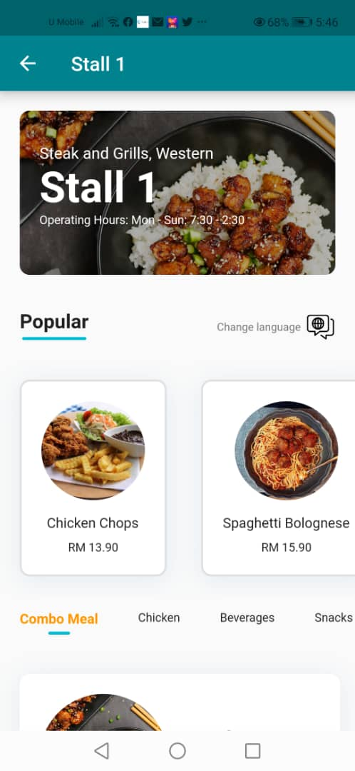

*Diagram 3.3.13 Homepage Diagram 3.3.14 Menu Page*

#### 3.3.2.4 Recoverability

The menu module in the online food ordering system will allow the user to recover from the error. For example, when the user adds wrong foods to the menu, the online food ordering system will allow the user to delete the food by clicking the dustbin icon beside the edit button. Moreover, if the user accidentally clicks the delete button of the specific food, the online food ordering system will ask a confirmation from the user. The user can clicks no to remain the specific food and return back to the manage menu page.

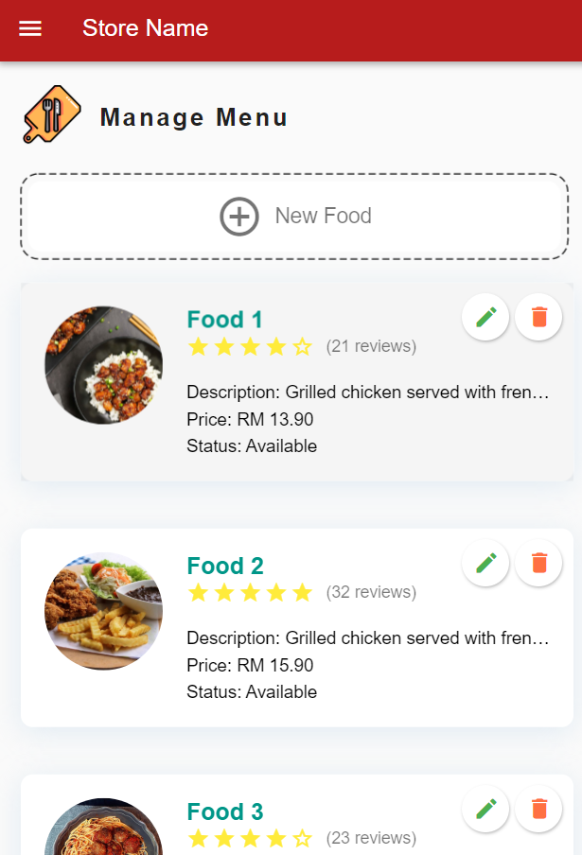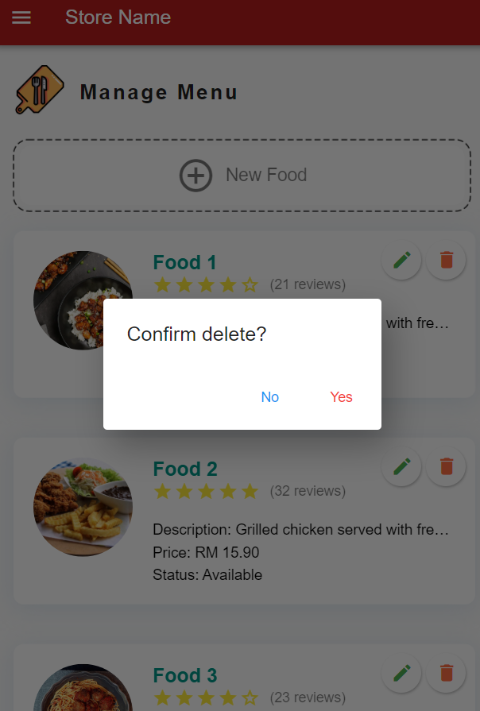

*Diagram 3.3.15 Manage Menu Page Diagram 3.3.16 Confirmation for delete*

#### 3.3.2.5 User Guidance

The menu module of the online food ordering system will provide meaningful feedback when errors occur. For example, when the user forgets to enter the food name while editing the food details, the online food ordering system will display a food name is required message to the user. This can guide the user when the user makes some error.

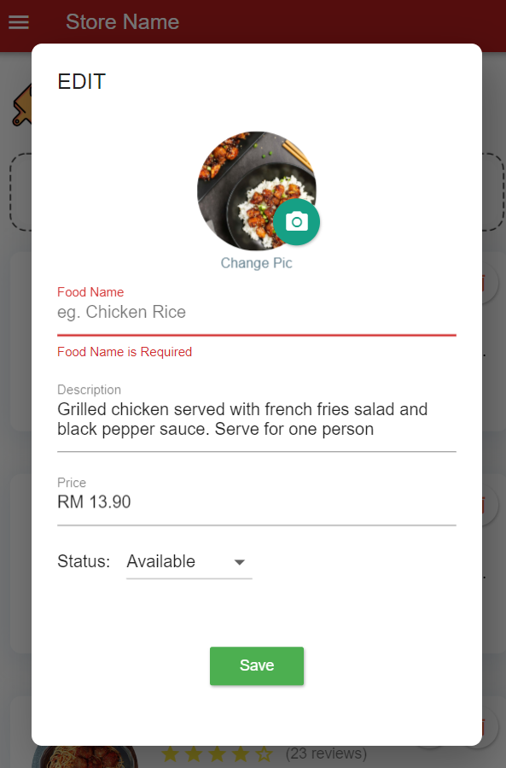

*Diagram 3.3.17 Edit Food Details Page*

### 3.3.3 Order Module

#### 3.3.3.1 User Familiarity

The interface of the order module of the online food ordering system is quite similar to the order module in other food ordering systems that can be found in the market. For example, the user orders the foods by adding the foods to the cart and then checkout after choosing the foods. This can help the user easier to learn and understand the operation in the system.

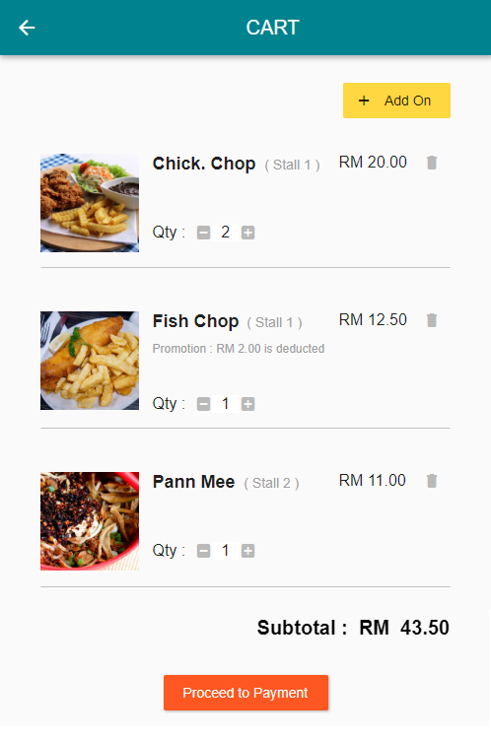

*Diagram 3.3.18 The interface of the order module is similar to the order module in other systems.*

#### 3.3.3.2 Consistency

The order module of the online food ordering system is displaying the foods in the cart in the same way which is the food’s details and the quantity of the food. This can help to reduce confusion of the users when they are making orders.



*Diagram 3.3.19 The order module is displaying all the foods in the cart in the same way.*

#### 3.3.3.3 Recoverability

The order module in the online food ordering system will allow the user to recover from the error. For example, when the user adds wrong foods to the cart, the online food ordering system will allow the user to delete the food by clicking the dustbin icon beside the food.



*Diagram 3.3.20 The order module allows the user to recover from error by deleting the wrong food selected.*

#### 3.3.3.4 Reduce the user’s Memory Load

The order module is displaying all the foods in the cart in one page and this allows the user is having limited short-term memory only. This can prevent the users from making mistakes when they handle too much info.



*Diagram 3.3.21 The order module displays all the information in one page.*

### 3.3.4 Payment Module

#### 3.3.4.1 User Familiarity

The interface of the payment module is having similar design as other existing food ordering systems. For example, the user is allowed to choose the payment method such as debit card, credit card and others which similar to other systems. This allows the user easier to learn the operation of the system.

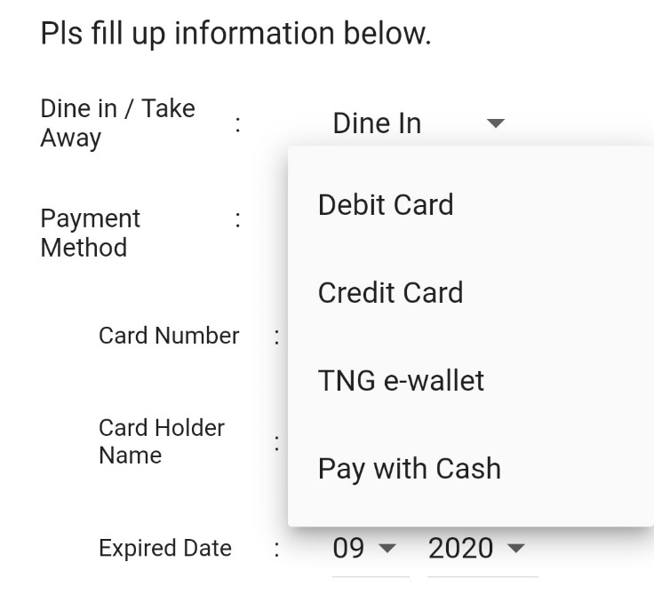

*Diagram 3.3.22 The user is allowed to choose their payment method which is similar to other payment module in the existing food ordering systems.*

#### 3.3.4.2 Consistency

The layout of the foods in the order summary of the payment module is all in the same format. All of the foods in the order summary is displayed in the form that the quantity follows by food details and then the price of the food. This can make the payment module easy to learn and reduce confusion of the users when they are paying.

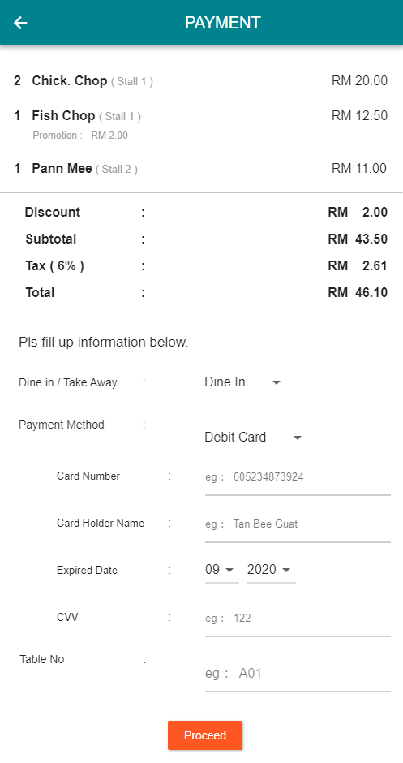

*Diagram 3.3.23 The payment module is displaying all of the foods in the order summary in the same format.*

#### 3.3.4.3 Minimal Surprise

The users of online food ordering system will never be surprised by the behaviour of the system when they are paying. For example, the payment module will show the receipt to the user, and when the user wants to quit from that page, the system will ask for the confirmation of the user.  If the user presses the OK button, then the user will proceed to the menu page, otherwise the user can click the return button on the phone to remain at the receipt page. Asking for the confirmation of the user can prevent the user being surprised by the system.

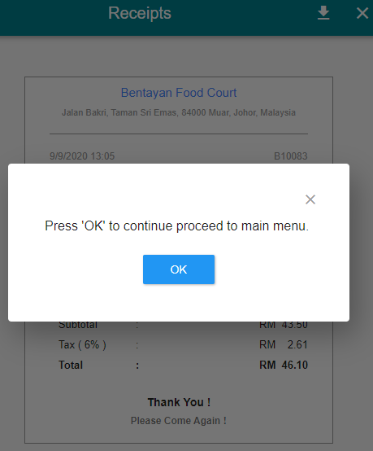

*Diagram 3.3.24 The payment module asks for the confirmation of the user to prevent the user being surprised by the system.*

#### 3.3.4.4 User Guidance

The payment module of the online food ordering system will provide meaningful feedback to the user when errors occur. For example, when the user forgets to enter the card number, the online food ordering system will display a card number is required message to the user. This can guide the user when the user makes some error.

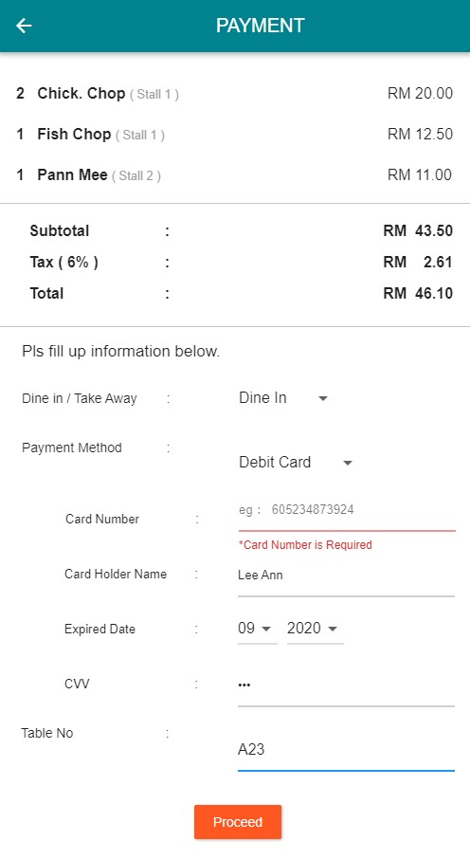

*Diagram 3.3.25 The online food ordering system is providing meaningful feedback to guide the user when they forget to fill in their card number and directly click the proceed button.*

#### 3.3.4.5 Recoverability

The payment module of the online food ordering system will allow the user to recover from the error. For example, when the user forgets to enter the debit card number and directly press the proceed button, the online food ordering system will allow the user to enter the card number again.



*Diagram 3.3.26 The online food ordering system is allowing the user to fill in the card number again if they forgot to do this before.*

#### 3.3.4.6 Reduce the User’s Memory Load

The payment module of the online food ordering system is showing all the information in one page. This can make the payment module easier to understand and prevent the users from making mistakes when they handle too much info. Besides, this module is displaying the summary of the order so the user will only have limited short-term memory.



*Diagram 3.3.27 The payment module is showing all information in one page and also showing the order summary.*

### 3.3.5 Membership Module

#### 3.3.5.1 User Familiarity

The interface of the order module of the online food ordering system is using terms and concepts which are drawn from the experience of the people who will most use the online food ordering system. For example, the user can register an account to login as a member to use the extra features. The terms rating, rating and others which are the extra features are same as the terms in other food ordering systems.

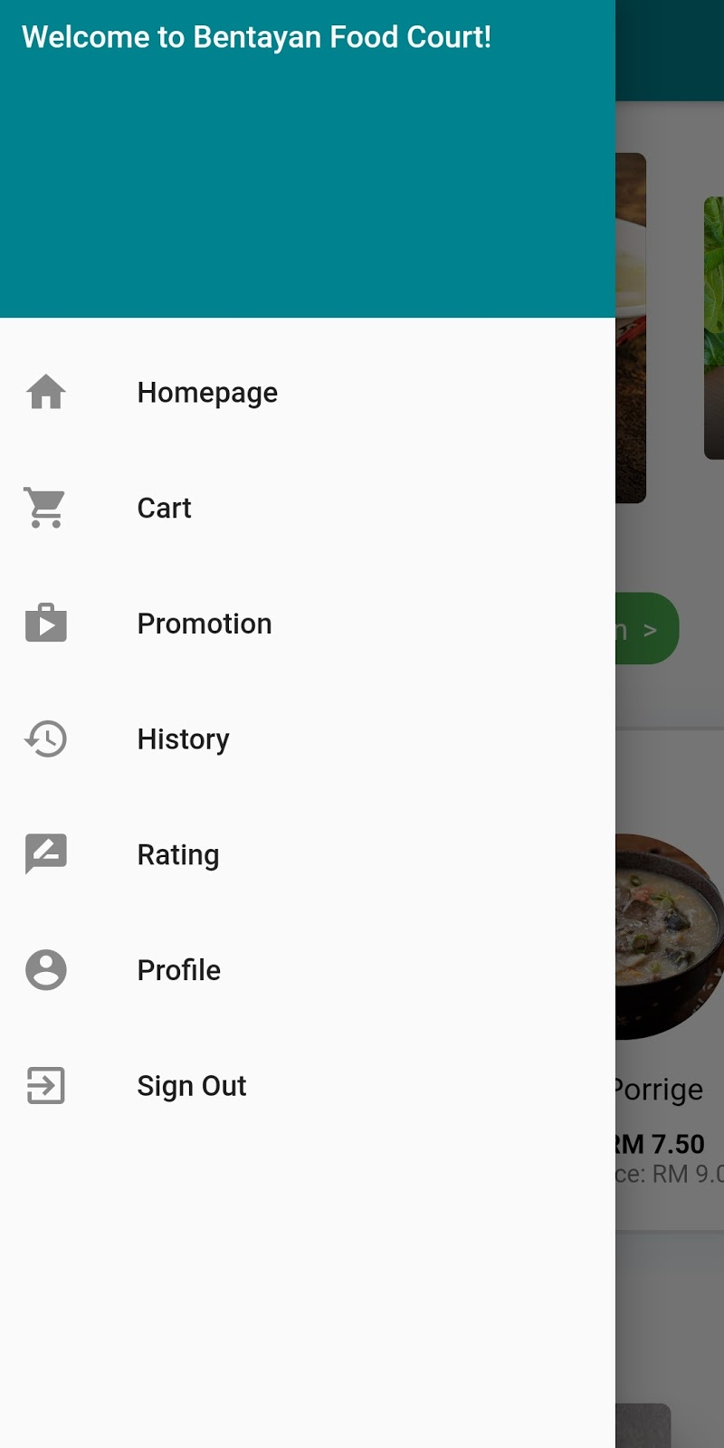

*Diagram 3.3.28 The terms promotion, history, rating, profile is the same as the terms in other food ordering systems.*

#### 3.3.5.2 Consistency

The membership module of the online food ordering system is displaying all the promotions in the same way which displays the promotion details on the picture of that food. This can make the membership module easy to understand and reduce confusion of the users when they are using the system.

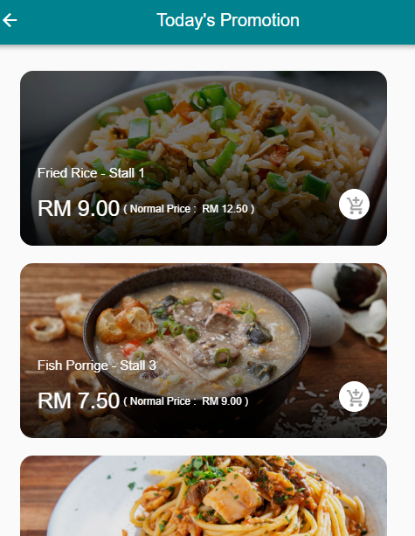

*Diagram 3.3.29 The membership module is displaying all the promotions in the same way.*

#### 3.3.5.3 Recoverability

The membership module of the online food ordering system allows the user to recover from the error. For example, the user is allowed to change their details such as gender, Email and others.

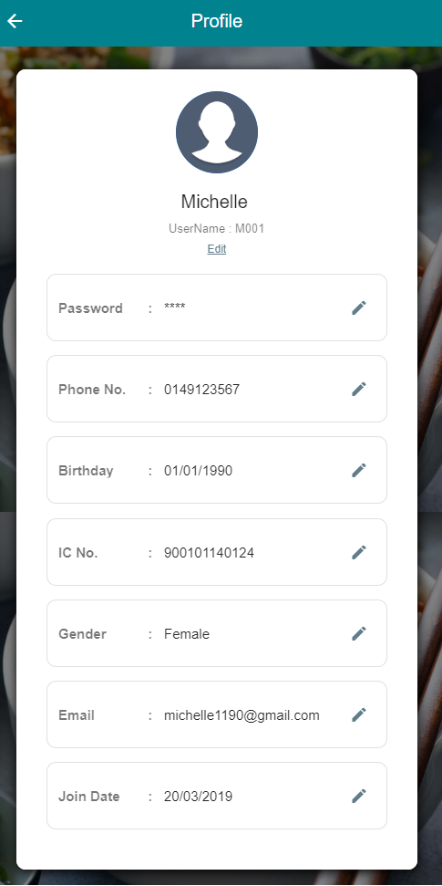

*Diagram 3.3.30 The membership module allows the user to edit their details if he/she has made an error.*

#### 3.3.5.4 Reduce the user’s Memory load

The membership module of the online food ordering system is showing the history the user had made before to help the user to remember some foods he/she prefers. This can ensure that the user will only have limited short-term memory and prevent them from making mistakes when they handle too much info.

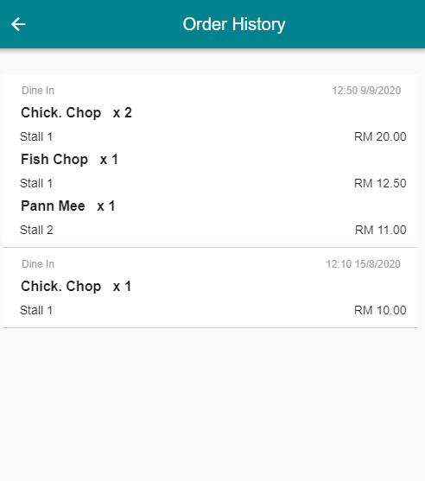

*Diagram 3.3.31 The membership module is showing the order history of the user.*

## References

David Hay. “A Repository Model – The Object-Oriented Design Model.” *TDAN.Com*, Jan. 2001, tdan.com/a-repository-model-the-object-oriented-design-model/4910.

Fatima Qayyum. “Srs (Software Requirement Specification Document).” *Slideshare.Net*, 19 May 2018, <www.slideshare.net/FatimaQayyum1/srs-software-requirement-specification-document>.

Gridnev, Andrei. “Non-Functional Requirements, Quality Attributes and Better Software Architecture.” *Medium*, 15 Jan. 2019, medium.com/@andreigridnev/non-functional-requirements-quality-attributes-and-better-software-architecture-855425310e60.

Haroon, M. Omar. “ORDER MANAGEMENT SYSTEM Software Requirements Specification.” *Www.Academia.Edu*, 17 Aug. 2016, <[www.academia.edu/28653436/ORDER\_MANAGEMENT\_SYSTEM\_Software\_Requirements\_Specification](http://www.academia.edu/28653436/ORDER_MANAGEMENT_SYSTEM_Software_Requirements_Specification)>.

“Incremental Model - Javatpoint.” *Www.Javatpoint.Com*, 2011, <[www.javatpoint.com/software-engineering-incremental-model](http://www.javatpoint.com/software-engineering-incremental-model)>.

“Incremental Model in SDLC: Use, Advantage & Disadvantage.” *Www.Guru99.Com*, <[www.guru99.com/what-is-incremental-model-in-sdlc-advantages-disadvantages.html#:~:text=Incremental%20Model%20is%20a%20process](http://www.guru99.com/what-is-incremental-model-in-sdlc-advantages-disadvantages.html#:~:text=Incremental%20Model%20is%20a%20process)>.

Kulkarni, Hrishikesh, et al. *Software Development Aspects of a Mobile Food Ordering System*.

Leong, Wai, et al. “Food Ordering System Using Mobile Phone A REPORT SUBMITTED TO.” LEONG WAI HONG, 20 Apr. 2016.

“Muar Food Hunt.” *Muar Food Hunt*, 9 June 2013, hearfishsays.blogspot.com/2013/06/food-hunting-muar.html.

Nick Babich. “The 4 Golden Rules of UI Design | Adobe XD Ideas.” *Ideas*, Nick Babich, 7 Oct. 2019, xd.adobe.com/ideas/process/ui-design/4-golden-rules-ui-design/.

RAHUL. “Incremental Model In Software Engineering : SDLC.” *Techno Trice*, 4 Aug. 2016, <[www.technotrice.com/incremental-model-in-software-engineering/](http://www.technotrice.com/incremental-model-in-software-engineering/)>.

“Requirement Gathering Techniques - Tutorialspoint.” *Tutorialspoint.Com*, 2019, <[www.tutorialspoint.com/business\_analysis/business\_analysis\_requirement\_gathering\_techniques.htm](http://www.tutorialspoint.com/business_analysis/business_analysis_requirement_gathering_techniques.htm)>.

“Test Plan – SOFTWARE TESTING Fundamentals.” *SOFTWARE TESTING Fundamentals*, softwaretestingfundamentals.com/test-plan/.

“The Problem In Existing System Information Technology Essay.” *UKEssays.Com*, 1 Jan. 1970, <[www.ukessays.com/essays/information-technology/the-problem-in-existing-system-information-technology-essay.php#:~:text=Cannot%20Upload%20and%20Download%20the](http://www.ukessays.com/essays/information-technology/the-problem-in-existing-system-information-technology-essay.php#:~:text=Cannot%20Upload%20and%20Download%20the)>.

“WE LOVE MUAR.” *Www.Welovemuar.Com*, <[www.welovemuar.com/en/food/snacks/bentayan-food-court](http://www.welovemuar.com/en/food/snacks/bentayan-food-court)>.

“What Are Constraints in Project Management?” *Wrike.Com*, 2019, <[www.wrike.com/project-management-guide/faq/what-are-constraints-in-project-management/](http://www.wrike.com/project-management-guide/faq/what-are-constraints-in-project-management/)>.

“What Are The Quality Attributes?” *Softwaretestinghelp.Com*, 31 Aug. 2007, <[www.softwaretestinghelp.com/what-are-the-quality-attributes/](http://www.softwaretestinghelp.com/what-are-the-quality-attributes/)>.

Yasuharu Nishi. “Viewpoint-Based  Test Requirement Analysis Modeling and Test Archite….” *Slideshare.Net*, 9 Dec. 2015, <www.slideshare.net/YasuharuNishi/viewpointbased-test-requirement-analysis-modelingand-test-architectural-design>.

‌

‌